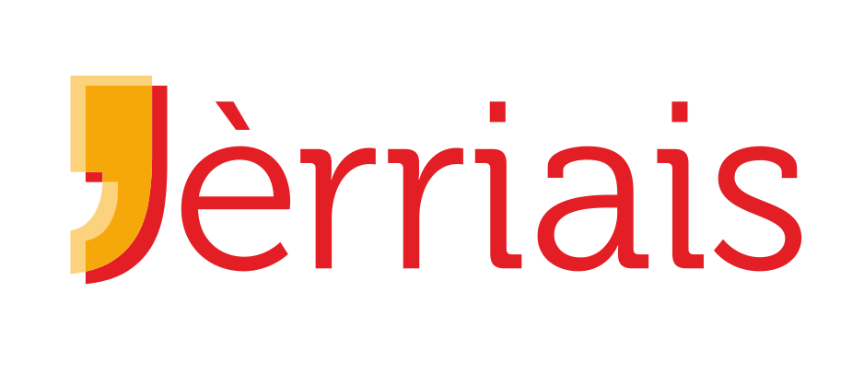
L’Office du Jèrriais – Jèrriais Teaching Service
Les Mousses, les Jannes Gens, l'Êducâtion et l'Agenceté
PO Box 142
St Saûveur
Jèrri JE4 8QJ

08 Novembre 2023

Chièrs pathents

Jèrriais Section of the Jersey Eisteddfod

Each year, we celebrate the achievements of our Jèrriais learners and invite them to participate in the Jèrriais Section of the Jersey Eisteddfod. This academic year, the Eisteddfod will be taking place on Friday 19th January 2024 at St Ouen’s Parish Hall and your child has expressed an interest in taking part.

If there are sufficient participants from your child’s school, then transport will be provided, however it might be necessary for you to transport your child to and from the Parish Hall, if it is convenient to do so. We will confirm these arrangements, as well as the time of your child’s performance(s) once all entries have been received.

Family and friends are very welcome to attend to support the participants. Please note that electronic devices should be switched off during the event and unauthorised recording and photography, both during performances and backstage, is strictly forbidden. The Jersey Eisteddfod takes no responsibility for images that may appear on any social media without permission.

In order for your child to take part in the Eisteddfod, please carefully complete the attached entry form and return it to your child’s Jèrriais teacher no later than Friday 1st December. For your convenience, the entry form can also be completed online. To do this, go to the Eisteddfod section of the Learn Jèrriais website, https://tinyurl.com/mr42s5fj

If you have any questions, please do not hesitate to ask your child’s Jèrriais teacher or contact me directly at b.spink@jeron.je.

Mèrcie bein des fais

BSpink

Ben Spink
Chef dé l’ensîngn’nie du Jèrriais (Head of the Jèrriais Teaching Service)

The Jèrriais Teaching Service will store your information securely. Please find a full copy of our Privacy Notice under ‘Resources’ on the Learn Jèrriais website: www.learnjerriais.org.je

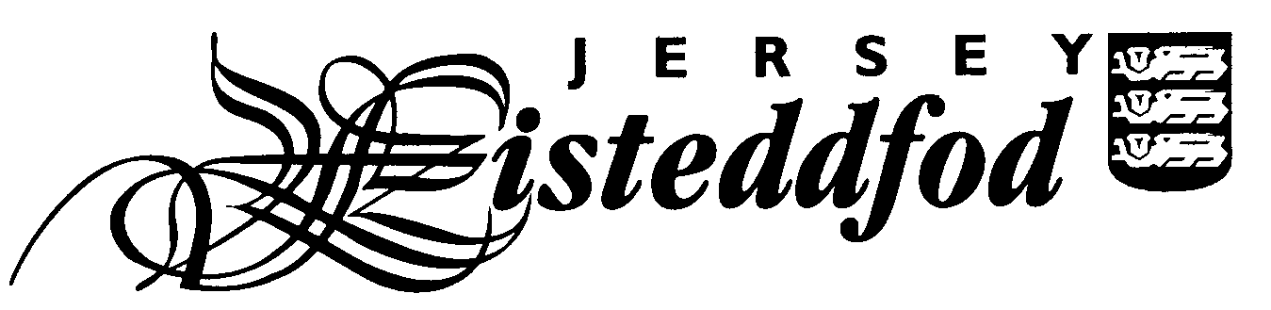
ENTRY FORM – JÈRRIAIS SECTION
For official use only
Competitor No.
JUNIOR ENTRIES (AGE 18 OR UNDER)

Closing date for entries is Friday 1st December 2023

PLEASE USE BLOCK CAPITALS

Full Name of Competitor: _________________________________________________________________

School and Year Group or Class: ____________________________________________________________

Age on 31st January 2024: ____________

Please complete the table below indicating which class numbers your child is entering and the pieces they are performing. This information can be found in the Eisteddfod section on www.learnjerriais.org.je or your child’s Jèrriais teacher will be able to help.

There is an entry fee of £1 for each class which will be paid by the Jèrriais Teaching Service and Le Don Balleine Trust.

Class No | Title of Piece | Entry Fee (for official use only)

Please tick to give permission for photographs to appear in the local media and on social media
Please tick to give permission for your child’s full name and school to be printed in the programme
and in the results article in the Jersey Evening Post

Please tick to confirm you have read the Festival Rules *

Please tick to confirm you have read the Jersey Eisteddfod Privacy Statement *

Signature of Parent: ____________________________________________________

Contact email address: __________________________________________________

Please return this form no later than Friday 1st December to your child’s Jèrriais teacher.

* You can find the Jersey Eisteddfod Privacy Statement and Festival Rules on the Jersey Eisteddfod website www.jerseyeisteddfod.org.je.
If you do not have access to the internet, you can request a paper copy from the Jèrriais Teaching Service.

