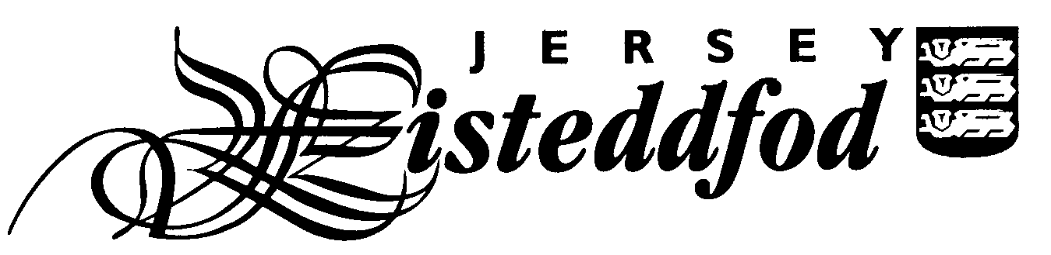
ENTRY FORM – SECTION DU JÈRRIAIS
For official use only
Competitor No.
JUNIOR PAIR / GROUP ENTRIES

Entries close Friday 27th September 2019

PLEASE COMPLETE ONE FORM PER GROUP ENTRY. PLEASE USE BLOCK CAPITALS.

Title of piece: ___________________________________________________________________________

Class No: _____________

Please complete the table below to provide the names of each child in the group. There is an entry fee of £2 per pair / group.

Full Name | School | Age on 31st August 2019

Please tick to indicate all parents of the children in this group give permission for photographs to appear in the local media
Please tick to confirm all parents of the children in this group have read the Festival Rules *

Please tick to confirm all parents of the children in this group have read the Jersey Eisteddfod Privacy Statement *

Signature of Parent: _____________________________________________________

Contact email address: ____________________________________________________________________

Please return this form with the £2 entry fee to your child’s Jèrriais teacher. Please make all cheques payable to ‘The Jersey Eisteddfod’.

If the pair / group has chosen to enter an ‘own choice’ class please ensure you enclose a copy of the piece they have chosen to perform for the adjudicator.

* You can find the Jersey Eisteddfod Privacy Statement and Festival Rules on the Jersey Eisteddfod website www.jerseyeisteddfod.org.je. If you do not have access to the internet you can obtain a paper copy from the teaching team at L’Office du Jèrriais.

