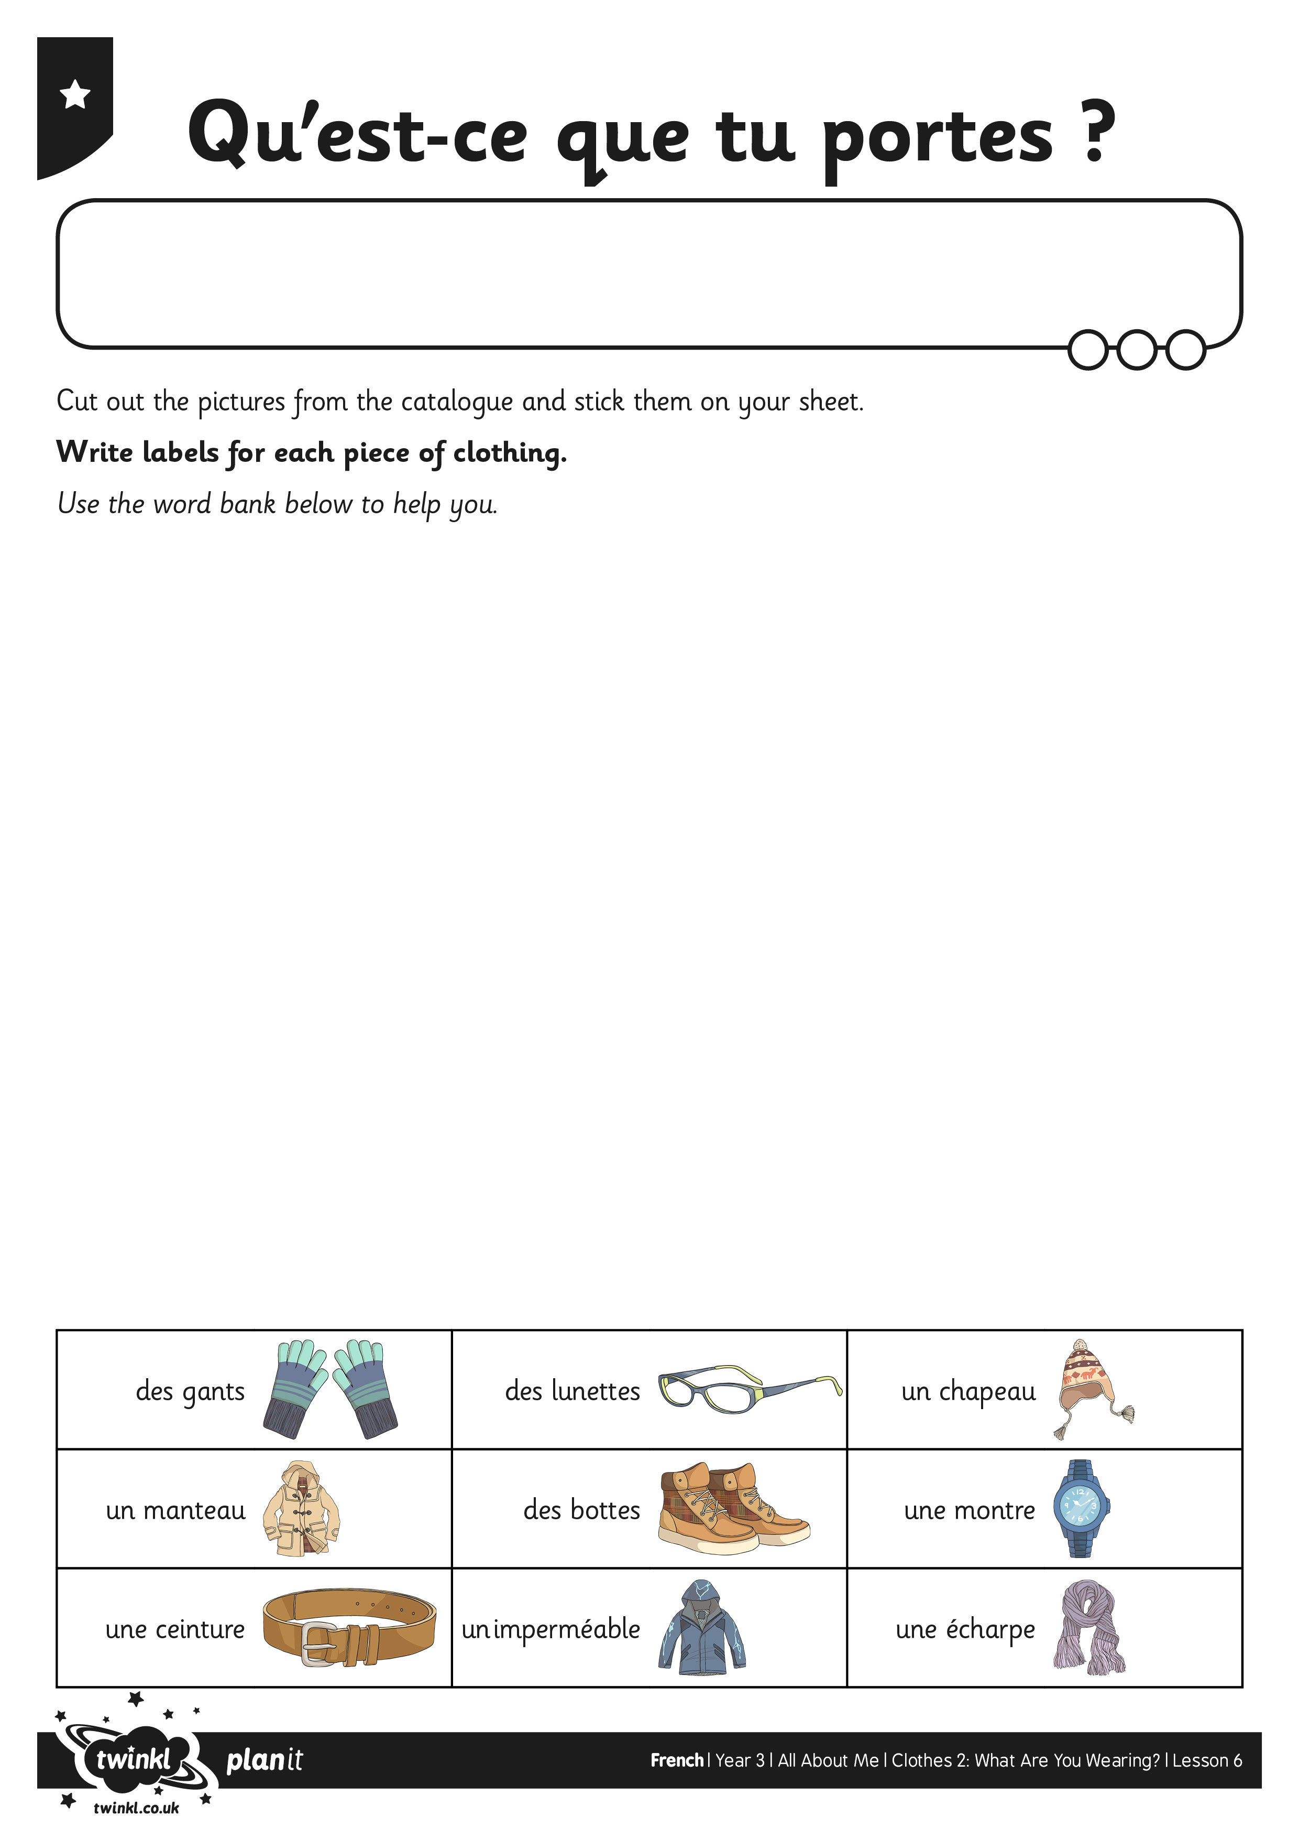

I can say what I am wearing.
I can ask someone else what they are wearing.
Tch'est qu' tu'es à porter?
Draw a picture of yourself wearing an outfilt. Label each of the articles of clothing.

CHALLENGE
Write 2 sentences about what you are wearing.

